**Residential Management Database**

***INTRODUCTION:***

‘Citadel’ is a residential area that has 3 storey buildings with 1/2/3 bhk flats . Most of these flats have been rented out to students and families, while the others have the landlord residing. A Management Committee was hired in order to take care of the maintenance issues of the residential area and of the rental procedure which involves activities like, collecting monthly rent , keeping track of the due payments and maintaining the lease details of the tenants etc.

***PURPOSE:***

A lot of paperwork is involved in each of these activities like keeping a track of the flats and their rental prices, lease details , the personal details of the landlords ,the tenants and the people appointed for the maintenance activities like plumbers, pest control, electricians, cleaners; Collecting the rent on time and maintaining a record of the delayed payments .Keeping a track of the maintenance and parking bill and the total payment due for each flat.

We will be creating a database that would eliminate the need to file the information of the above entities involved and will ensure smooth and easy tracking of people and activities for the Management committee.

**The ER Diagram**

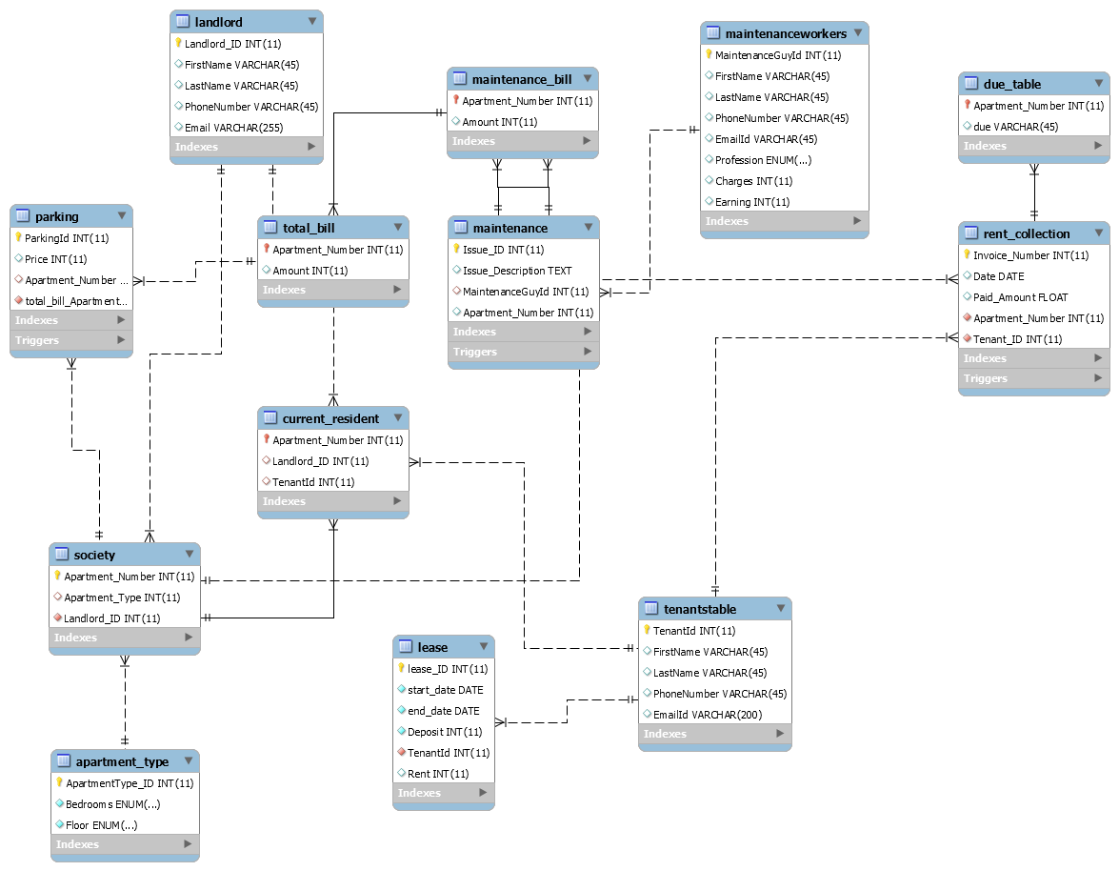

The following features have been implemented in the project.

1. Triggers
2. Stored procedures
3. Views
4. Calculations to track the payments and due amount each time a new payment is made.

The following are the screen shots based what has been implemented in the project and the reasons for it:

**Triggers:**

The due_table_entry trigger gets fired once an entry is made in the rent_collection table , the purpose of this trigger is to check whether the tenant is making a fresh payment of the rent or if he has already paid a part of the amount and has certain dues , which he pays time to time.

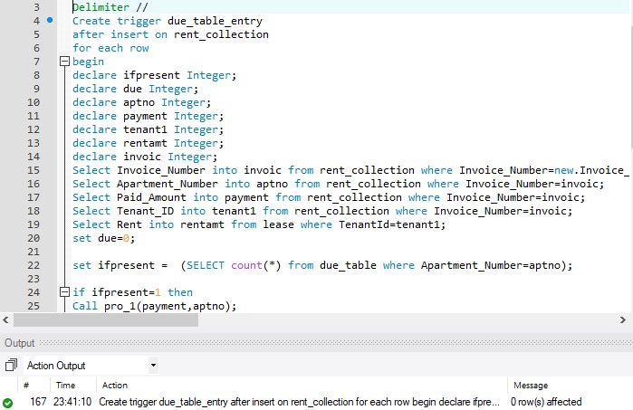

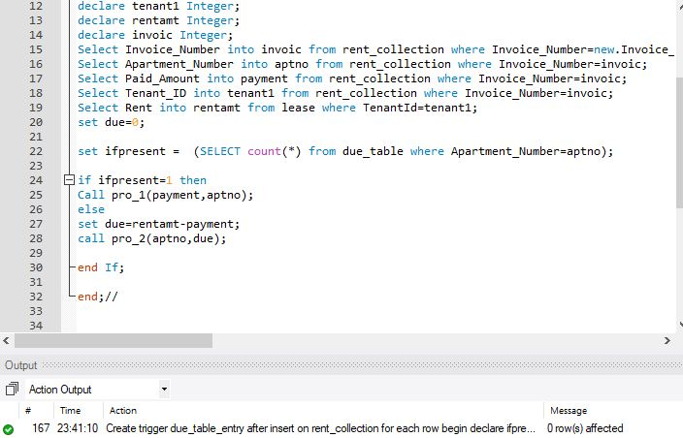

An entry is made for apartment 5 in the rent_collection table ,

this entry consists of the current payment that the tenant has made , in the trigger we using an if then else statement if this payment is initiated , if yes then check dues , if not then make a new entry in due table mentioning the dues.

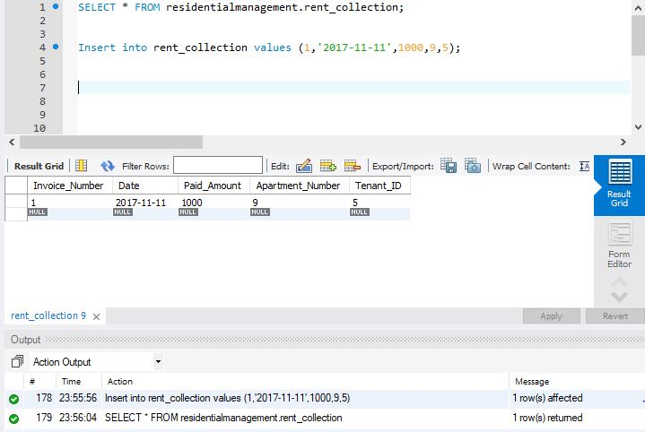

The rent value minus the payment made gives us the due amount that is stored in due table.

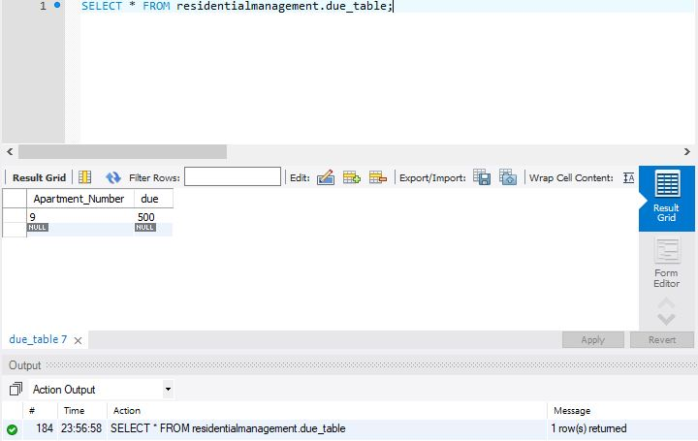

When we make a second payment/transaction for the apartment number in the rent_collection table ,

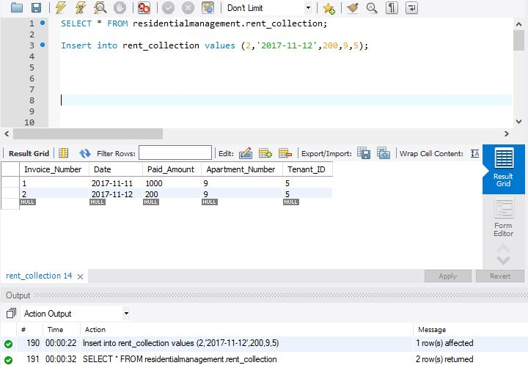

The due table gets updated with the new due amount.

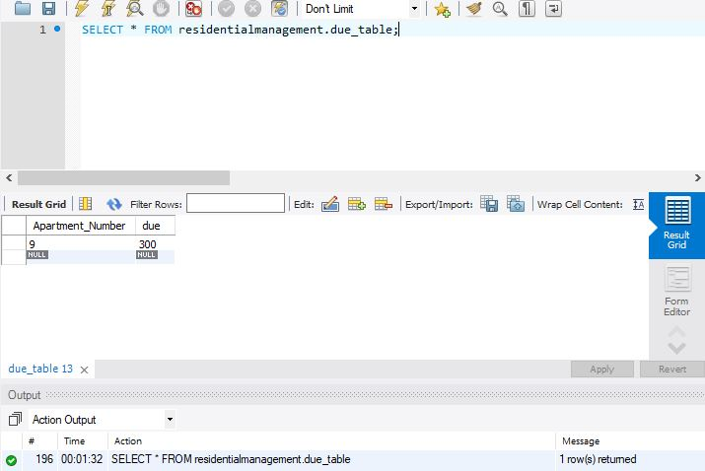

The maintenance_bill_trig is a trigger that performs 3 functions once a maintenance issue entry is made in the maintenance table

1.the charges for the particular maintenance worker is checked and these get added to the maintenance bill

2.this value is also added to the total__bill (which will also contain the parking rent) for each apartment.

3. Also , the total earning of the maintenance worker gets updated

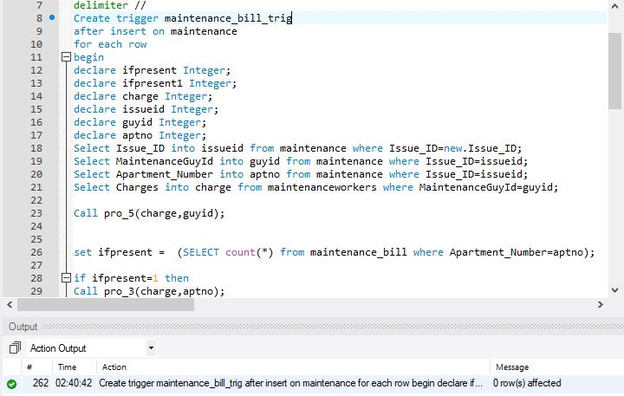

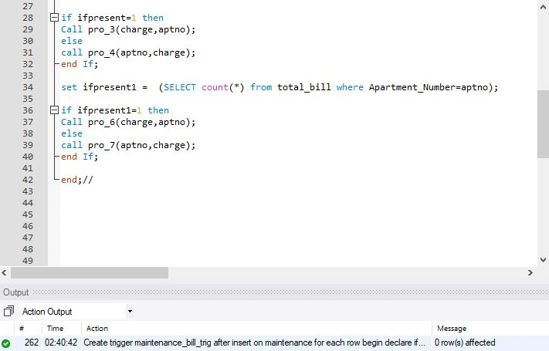

These are the maintenance entries in the table.

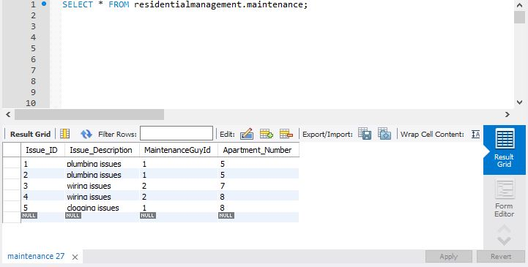

Based on the above maintenance issues , for each maintenance_worker his earning is calculated and stored in the table.

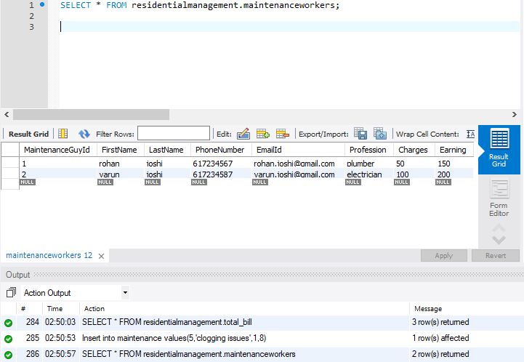

The maintenance_bill is generated for each apartment from the above entry in maintenance table.

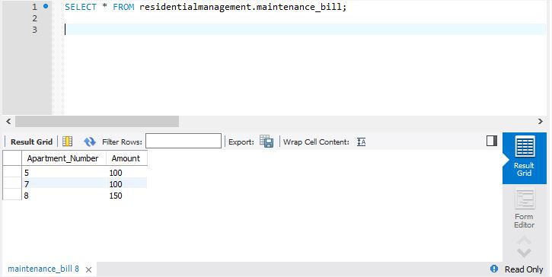

The total_bill is generated for each apartment from the above entry in maintenance table.

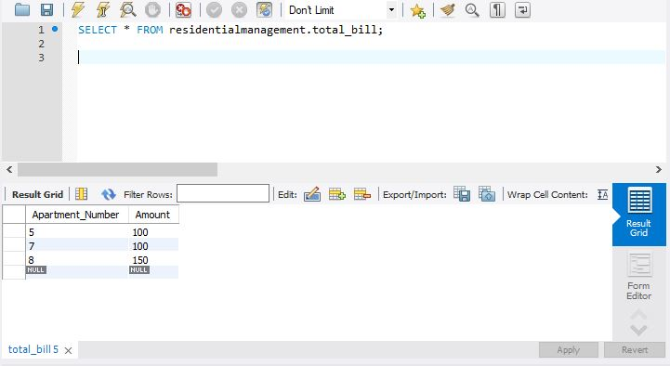

Parking_total_bill Trigger: for calculating the parking bill for every apartment that has one or multiple parkings , this amount get directly added to the total bill amount .

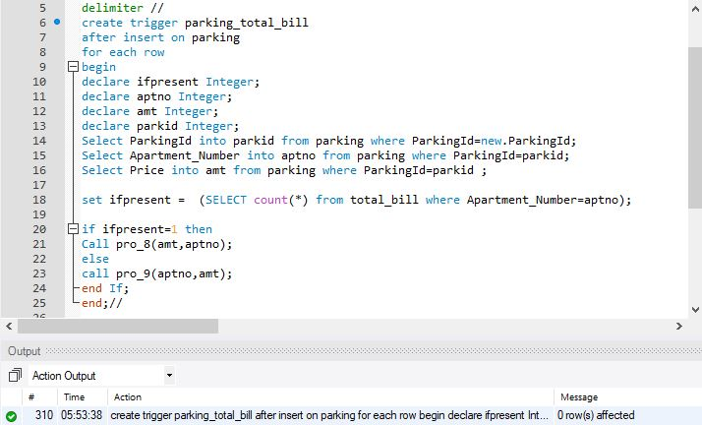

When an entry is made in the parking table , the trigger adds the parking amount vale to the total bill amount for that particular apartment number.

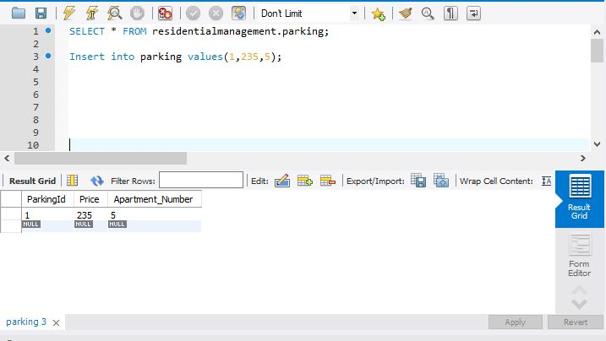

***Total bill is reflecting the maintenance bill and parking amounts.***

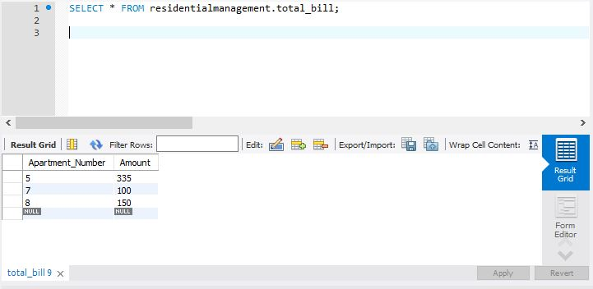

***Stored procedures :***

The stored procedures have been implemented in order to calculate the values and to make insert or update queries.

In stored procedure 1, the due value in due table is updated with the calculated value.

In stored procedure 2, if the particular apartment isn’t present in the due table , a row is inserted for it.

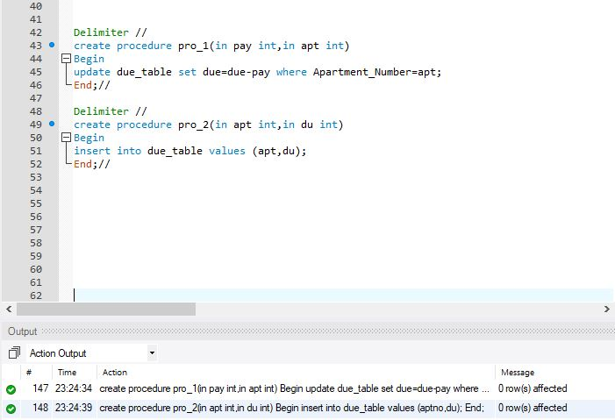

In stored procedure 3,4,5,6,7,8,9 similar calculations are performed for maintenance bill amount and earning of maintenance worker and total bill amount.

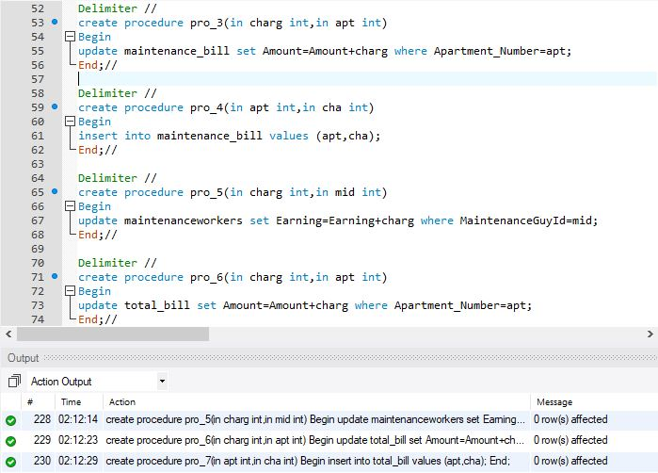

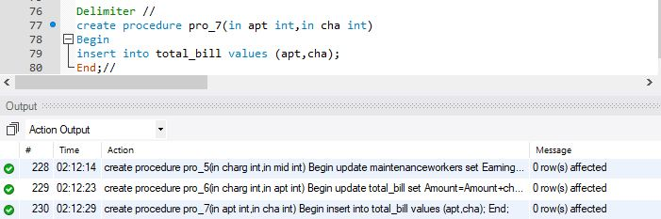

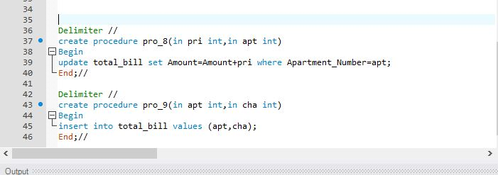

***Views***

This Apartment_details_view uses nested inner joins to give detailed view of the apartment details , its features and the landlord details.

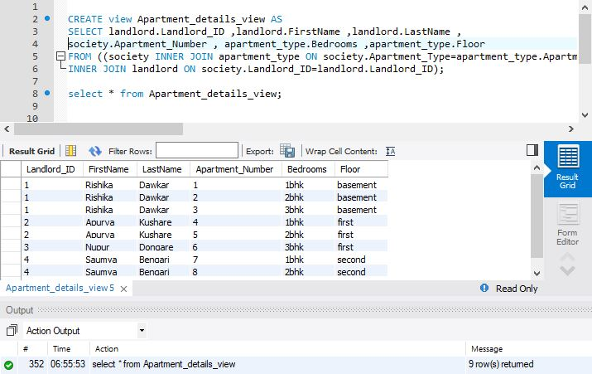

***THANK YOU.***